Advanced SQL Exercise for Online Retail Store

**Exercise 1 - Ranking and Window Function**

**Goal** - Use ROW_NUMBER(), RANK(), DENSE_RANK(), OVER(), and PARTITION BY.

Scenario:

Find the top 3 most expensive products in each category using different ranking function

**Schema SQL -**

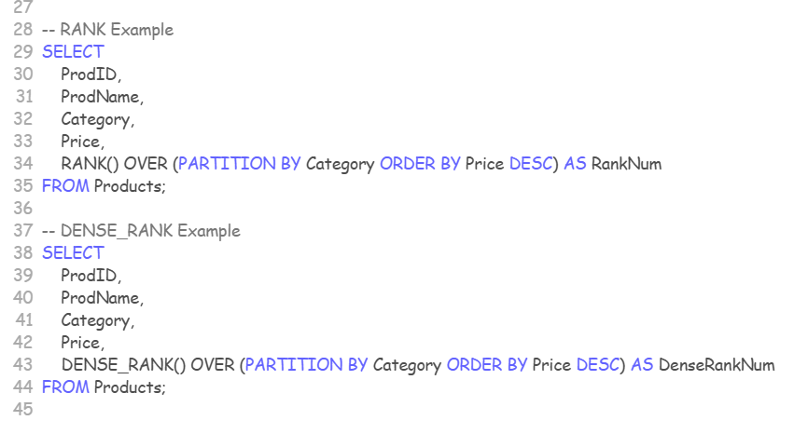

**Query SQL -**

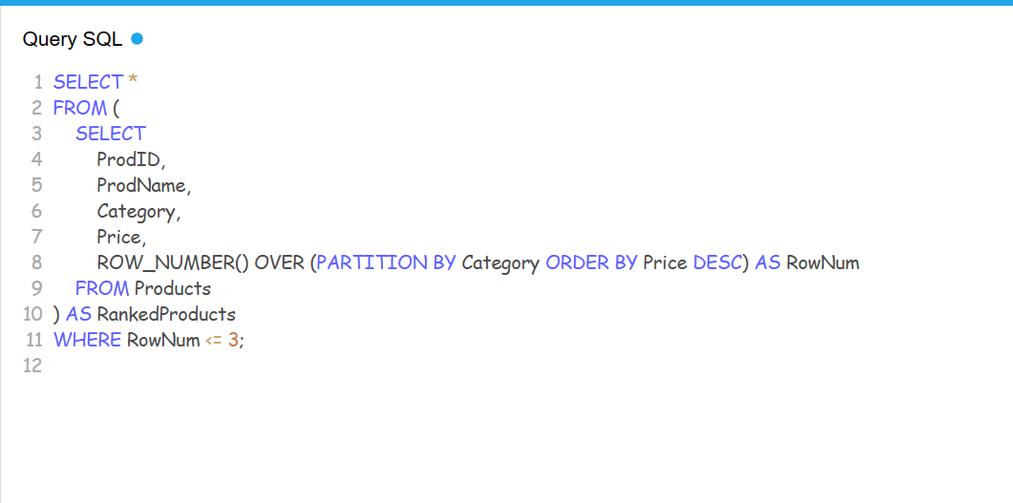

**Output -**

